Report for 10 Weeks by: Sherzod Ulashev
Weekly Report: Week 1
1. Project Overview
This week, I started working on a mobile landing page for a coffee shop called "Sher’s Cafe". The main goal was to plan the structure and organize the workspace.
2. What I did (Tasks)
- GitHub Setup: I created a new repository on GitHub. This is important for saving my work and showing my progress.
- Figma Design: I used Figma to create a wireframe for the website. I chose the iPhone 14 & 15 Pro screen size.
- Layout Structure: I designed the main parts of the page:
  - A Header with the name of the cafe.
  - A Hero Section (a placeholder for the main photo).
  - An About Us section to describe the shop.
  - A Menu list with items like Tea, Coffee, and Cola.
  - A Find Us footer for the location and address.
3. What I learned
- I learned how to use Figma for basic mobile design.
- I learned that a wireframe should be simple (only black, white, and grey) to focus on the layout, not the colors.
- I practiced how to organize folders in a GitHub repository
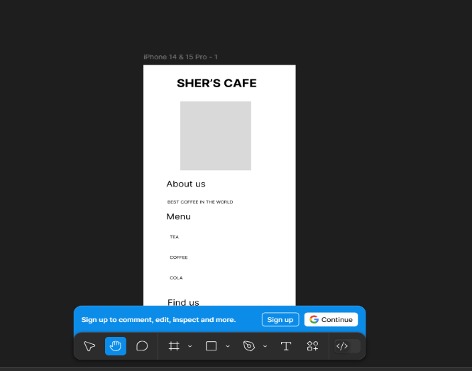
Weekly Report: Week 2
. What I did (Tasks)
- Visual Design: I updated the Figma project with a modern "Coffee Shop" aesthetic.
  - Color Palette: I chose warm, coffee-themed colors (brown and cream) to create a cozy feeling.
  - High-Quality Imagery: I replaced the placeholders with real photos of coffee and desserts.
  - Typography: I selected clean, readable fonts for the headers and descriptions.
- Component Detailing: I improved the Menu section by adding icons and price placeholders. I also styled the "About Us" section with a better layout.
- GitHub Update: I updated my repository documentation to reflect the new design changes and uploaded the final design screenshots.
- Technical Preparation: I started planning the HTML structure and CSS classes needed for the coding phase.
. What I learned
- I learned how to create a visual hierarchy using different font sizes and colors to draw attention to important information.
- I practiced working with images and masks in Figma to make the layout look polished.
- I understood how to balance text and white space to improve mobile readability.
Weekly Report: Week 3
1. Project Overview
This week, I started the development phase. My main focus was converting the Figma design into functional code using HTML5 and CSS3.
2. What I did (Tasks)
- Environment Setup: I set up my coding environment using Visual Studio Code. I created the project folder and the main files: index.html and style.css.
- HTML Structure: I wrote the semantic HTML structure for the landing page. This includes:
  - The Navigation bar and logo area.
  - The Hero section with a placeholder for the main image.
  - The Service/About section.
  - The Menu grid where the coffee and tea items will be displayed.
- Coding Standards: I used clean code practices, like adding comments and using proper indentation, to make the code easy to read.
- GitHub Sync: I committed my first lines of code to the GitHub repository to track my progress.
3. What I learned
- I learned how to translate a visual design from Figma into HTML tags.
- I practiced using Semantic HTML (like <header>, <section>, and <footer>) to make the website better for search engines.
- I understood how to link a CSS file to an HTML document to prepare for styling.

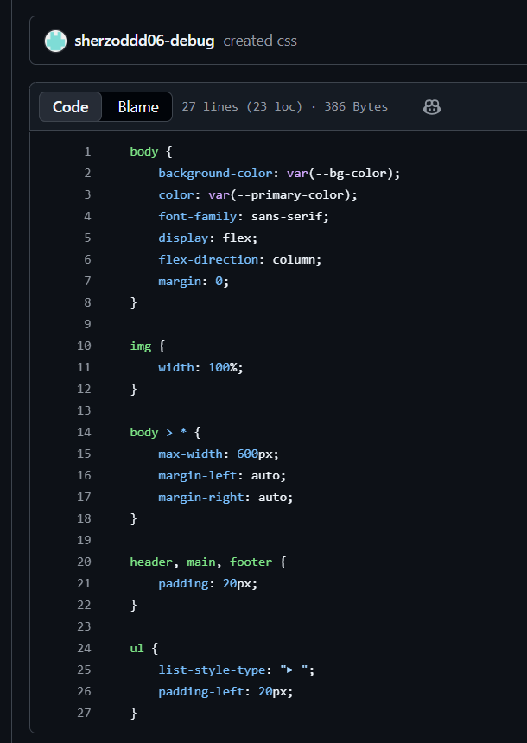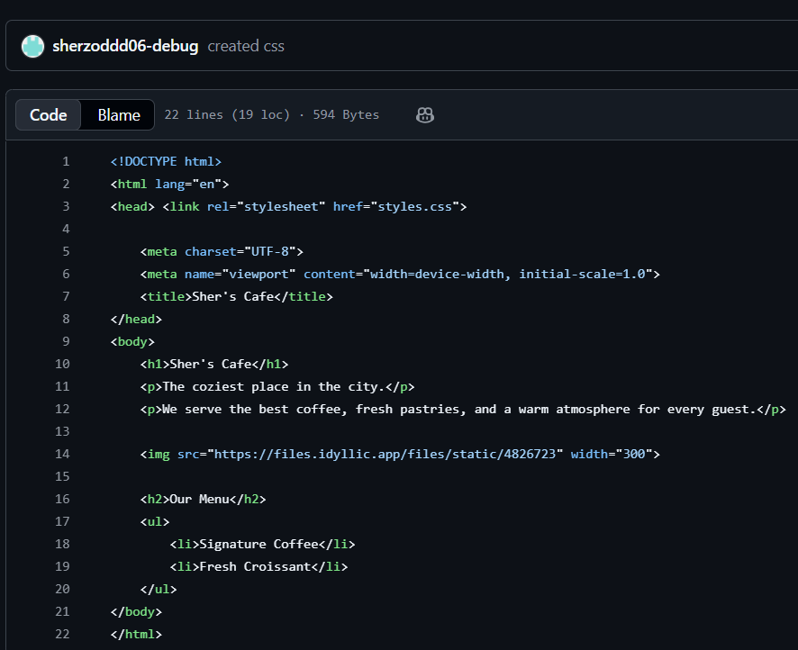
Weekly Report: Week 4
2. What I did (Tasks)
- Hosting Setup: I used the Pantheon platform to create a live environment for my website. This allows the site to be accessible online.
- CMS Installation: I installed and configured WordPress as the main platform for "Sher’s Cafe".
- Security Configuration: I installed the Wordfence plugin to protect the website from security threats and unauthorized access.
- Page Creation: I developed the core structure of the site by creating three main pages:
  - Home Page: The main landing area with the brand identity.
  - Menu Page: A dedicated page displaying the coffee shop's products.
  - About Us / Contact: A page for the cafe's story and location details.
- Navigation Menu: I set up the main menu to link these three pages together for easy navigation.
3. What I learned
- I learned how to use cloud hosting platforms like Pantheon for web development.
- I understood the importance of web security and how to use plugins like Wordfence to protect a site.
- I practiced managing content and pages through a CMS dashboard instead of writing every line of code manually.
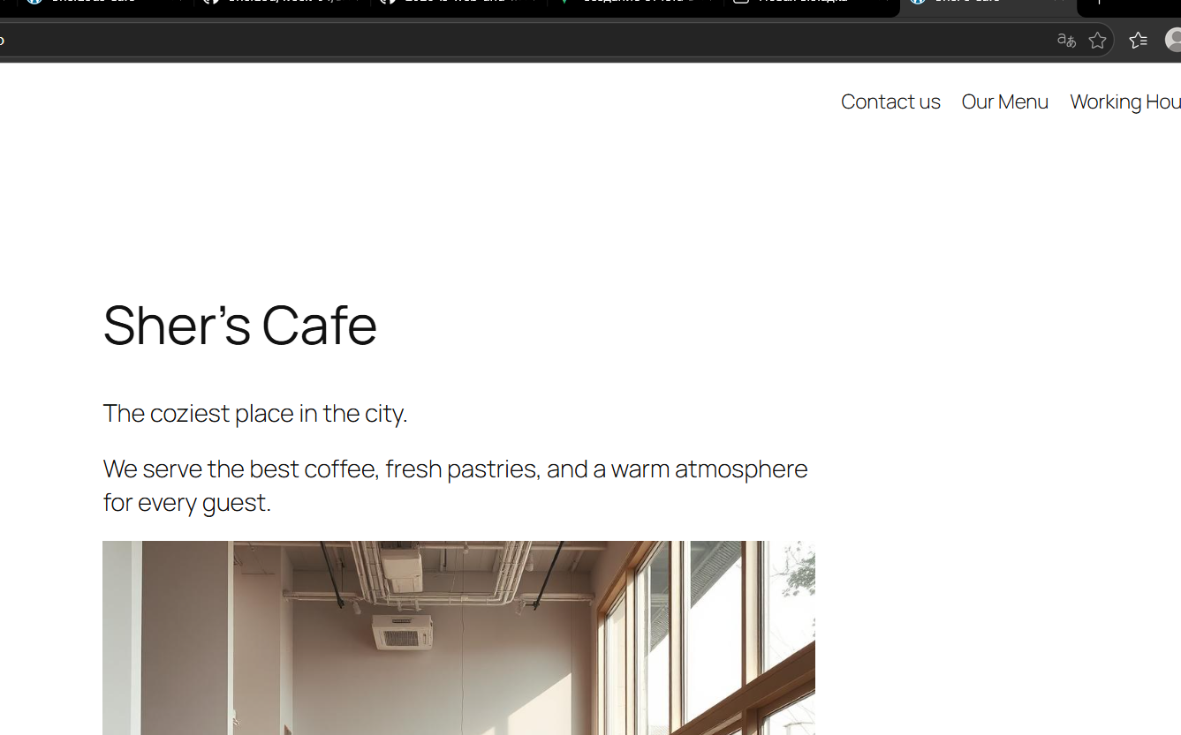
Weekly Report: Week 5
Project: Sher’s Cafe – Analytics and Conversion Tracking
2. What I did (Tasks)
- Google Tag Manager (GTM) Integration: I installed GTM on the website. This allows me to manage various tracking tags without changing the website's code manually every time.
- Google Analytics 4 (GA4) Setup: I connected the site to GA4 to collect data about visitor traffic, locations, and device types.
- Conversion Tracking: I configured a specific conversion event. I set up a trigger that fires whenever a user visits the /menu page. In GA4, this event is recorded as view_menu_page.
- Testing and Debugging: I used the GTM Preview mode to test if the tags were firing correctly when clicking on links.
- Documentation: I created an analytics-report.txt file in my GitHub repository to store all my tracking IDs and conversion descriptions.
3. What I learned
- I learned the difference between traffic (just visiting) and conversions (doing a specific action).
- I understood how GTM and GA4 work together to provide deep insights into website performance.
- I practiced the process of "debugging" tags to ensure that the data being collected is accurate.
Weekly Report: Week 6
1. Project Overview
This week, I integrated Artificial Intelligence (AI) into my workflow. The goal was to use AI tools to define a professional brand identity and improve the visual aesthetics of "Sher’s Cafe."
2. What I did (Tasks)
- Brand Persona Generation: I used AI to create a detailed brand guide. I defined the personality of the cafe as "Urban Chic & Warmth."
- Visual Identity Setup: * I selected a professional Color Palette: Deep Charcoal for text, Honey Gold for buttons, and Soft Linen for backgrounds.
  - I chose Typography using Google Fonts: Playfair Display for headings and Lato for body text.
- AI Design Improvement: I wrote specific prompts for AI to generate new UI elements and images.
- Comparison Documentation: I prepared "Before AI" and "After AI" screenshots to show how the design became more sophisticated and modern.
- Prompt Engineering: I documented all the prompts I used for generating the persona, the UI, and the images in a prompt.txt file.
3. What I learned
- I learned how to use Prompt Engineering to get high-quality results from AI tools.
- I understood how a consistent brand identity (colors and fonts) makes a website look much more expensive and professional.
- I practiced using AI as a "design assistant" to speed up the creative process.
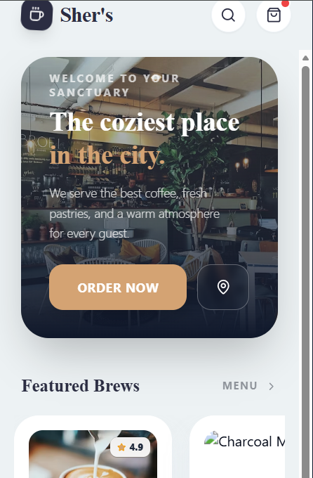
Weekly Report: Week 7
Project:
1. Project Overview
This week, I focused on two main goals: improving the technical performance of the website (SEO and Speed) and adding a functional "Loyalty Club" form to collect customer emails.
2. What I did (Tasks)
- Lead Generation Setup:
  - Installed the WPForms plugin to create a professional contact form.
  - Created the "Brew Crew" Loyalty Club form with Name, Email, and a mandatory GDPR checkbox for privacy.
  - Configured a custom "Thank You" message with a virtual coffee voucher for new subscribers.
- UI/UX Redesign:
  - Significantly improved the Hero Section with a larger heading and a full-width background image.
  - Added a "Featured Today" section with product cards for better engagement.
  - Implemented a clear Call-to-Action (CTA) button: "VIEW FULL MENU."
- Technical Optimization (Lighthouse Audit):
  - Performance (95%): Optimized images by converting them to WebP format and compressing them to improve loading speed (LCP).
  - SEO Improvement: Fixed the heading structure (H1, H2) and added meta titles and descriptions to help the site rank better on Google.
  - Accessibility (100%): Ensured the site is easy to use for everyone, achieving a perfect score.
3. What I learned
- I learned how to use Google Lighthouse to find and fix technical problems on a website.
- I understood the importance of GDPR compliance when collecting user data.
- I practiced Image Optimization techniques to make the site load almost instantly.
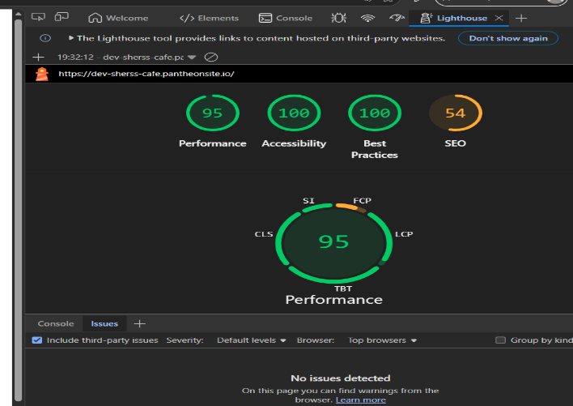
Weekly Report: Week 8
1. Project Overview
This week, I focused on improving the website's visibility on search engines and ensuring a professional appearance when shared on social media platforms.
2. What I did (Tasks)
- SEO Snippet Optimization: I used the RankMath plugin to edit how "Sher’s Cafe" appears in Google search results. I set keywords like "Coffee Shop Prague" and cleaned up the URL permalinks.
- Social Preview Setup: I configured the Open Graph settings so that when the website link is shared on Facebook or Twitter, it displays a high-quality preview image and an engaging description.
- Sitemap Generation: I generated an XML Sitemap (sitemap_index.xml). This "map" helps search engine bots crawl and index all the pages of my site more efficiently.
- Social Media Integration:
  - Added Social Icons to the website footer, linking to Instagram and Facebook profiles.
  - Added a "Share this Menu" button to the Menu page to encourage social sharing.
3. What I learned
- I learned that metadata is crucial for "Social Proof"—if a link looks good, more people will click it.
- I understood how a Sitemap acts as a guide for Google's bots to find and understand the structure of a website.
- I practiced Keyword Optimization to make the site more relevant for local coffee lovers.
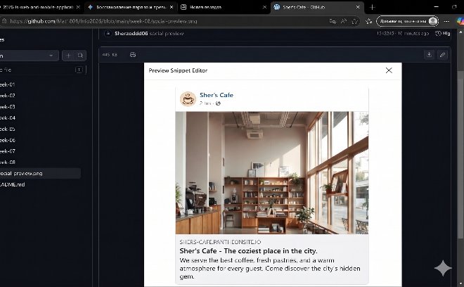
Weekly Report: Week 9
. What I did (Tasks)
- Digital Menu Creation: I added at least 3 types of products to the shop:
  - Simple Product: Espresso with a fixed price (e.g., 55 CZK).
  - Variable Product: Latte with options for different milk types (Cow, Oat, Soy).
  - Limited Stock Product: Chocolate Brownie with a low inventory setting to test stock warnings.
- Frictionless Checkout Setup: * Configured Payments: Enabled "Cash on Delivery" and renamed it to "Pay at Counter" for a better local experience.
  - Configured Shipping: Set the system to "Local Pickup" only.
- Order Testing (The "Ghost" Order): I performed a full test of the customer journey. It took exactly 4 clicks from adding to cart to placing the order.
- Inventory Management: Verified that the system automatically tracks stock. After a test order, the status successfully changed from "In Stock" to "Out of Stock" (or decreased), proving the inventory logic works.
3. What I learned
- I learned the difference between Simple and Variable products in e-commerce.
- I understood how to optimize the User Journey to make the checkout process fast and easy (only 4 clicks).
- I practiced managing a Digital Storefront, including stock control and payment settings.
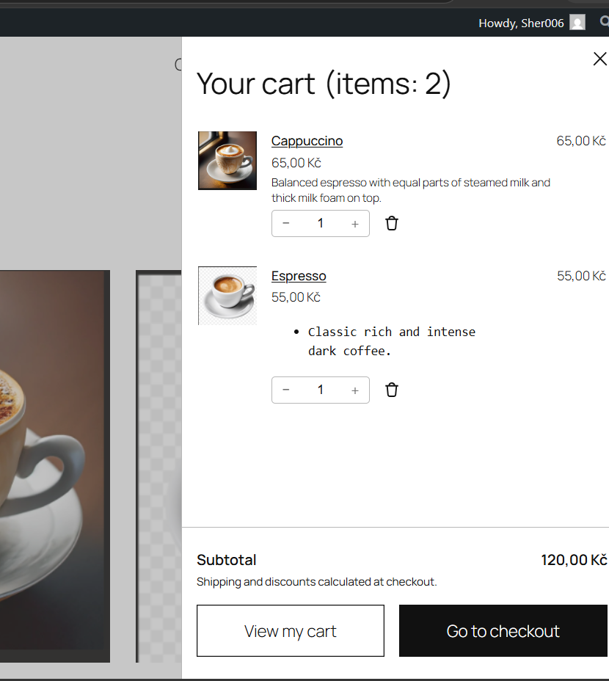
Weekly Report: Week 10
1. Project Overview
In the final week of the project, I focused on customer retention strategies and website maintenance. I implemented automated marketing tools and ensured the site’s data is safe with a full backup system.
2. What I did (Tasks)
- Discount Strategy: I created a promotional coupon code: SHERCOFES.
  - Logic: 15% discount for orders over 100 CZK to encourage new customers to make their first purchase.
- Email Automation: Set up an automated "Welcome Email" for the "Brew Crew" loyalty club.
  - Trigger: The email is sent immediately after a user signs up.
  - Content: A warm welcome and the 15% discount code.
- Data Segmentation Strategy: I designed a plan to use customer data for targeted marketing. For example, customers who choose "Latte" as their favorite drink will receive specific updates about new milk options or syrups.
- Maintenance & Security: I performed a Full System Backup (Database, Plugins, Themes, and Uploads) to ensure the project can be restored in case of any technical failure.
3. What I learned
- I learned how to use coupons as a tool to increase the "Average Order Value" (AOV).
- I understood the power of Email Automation in building a relationship with customers without manual work.
- I practiced Data-Driven Marketing by segmenting audiences based on their personal preferences.
- I learned the importance of Regular Backups for professional website management.

